**CHAPTER 1**

**INTRODUCTION**

Motor Operated Valve (MOV) is an important item of Power Plant & Piping system. These valves are generally of large size and are used for different applications such as Pump discharge etc. Motor Operated Valves are often called as On-Off valves as the motors serve the purpose of fully opening or fully closing valves in pipelines. For example, cooling water lines, process pipelines where controlling of fluid is not required, motor operated valves can be used to fully allow or fully stop the fluid flow. These valves are not used for throttling purposes as they serve mainly On-Off service application.

Motor operated valves can be of various types e.g. Gate/ Ball/ Butterfly etc. with actuator control. Design of Motors and valves can be different. An electric motor is mounted on the valve and geared to the valve stem so that when the motor operates the valve will open or close. For this MOV, motor operated with actuator control from local panel or, from control room is required. There is a requirement of co-ordination among Piping-Electrical-Instrumentation-Process engineers and vendor for design and procurement of such motor operated valves.

* 1. **Problem statement**

Prior to the initiation of this project we noticed that there was a problem in handling the huge ball valves, which would require a lot of human effort and clumsy timings. In remote areas and radiation zones human interaction must be avoided and automation must be implemented. Certain valves are beyond human power which can allow gallons of fluids to flow through it.

In huge apartments plumbers / workers cannot reach the valve in time. In irrigation and power plants required amount of fluids cannot be monitored with human interference always.

Keeping these problems in mind we have come up with a solution which can solve all these problems in a single shot.

* 1. **Methodology**

To be starting with, selecting the ball valve 2 inch general used in domestic purpose.

Adding up, 90 degree turn valve of CPVC material came in the line of our ideology

We drilled a hole on one end of the handle of ball valve and passed a thread that held the weight across, so that the force required to the handle can be calculated.

Weights are added in the order 1,2,3,4,5 kg around 5.250 kg the valve turned the length from the center of the valve to the one end is 6 cm.

In order to calculate the torque, we have

T = W*r

Where, T = torque

W = weight

r = perpendicular distance

T = 5.250*6

= 31.5 kg-cm

So we incorporated motor of 45kg-cm

We went for the gear DC motor initially, though we got required torque, but it has continuous rotation which we don’t require because valve is quarter turn (90 degree).

Moving up, servomotor doesn’t have required torque

Later, we summed up all required characteristics and went for stepper motor, which has required step turn and programmable characteristics etc.

We used NEMA 34 stepper motor bipolar 45 kg-cm torque, input of 24 volt is selected

To run the stepper motor, we needed a driver which sends pulses in the relevance of volt and current to run motor.

So a driver being operated by Arduino signal hence it is introduced into the system

An open source microcontroller that is Arduino which operates the motor directly through driver with a given set of instruction from the program.

The program developed in such a way that a motor should turn 90 degree in clockwise and anti-clockwise

A SMPS (switched mode power supply) which supplies necessary voltage and current (24V and 5A) as per our requirement.

Fabricating the structure for final orientation of project, we fabricated a structure with columns which holds the motor upside down and a clamp along the valve handle

The motor shaft and clamp were connected such that for the shaft rotation clamp should rotate valve handle as per the given pulse.

* 1. **Scope of project**

Scope of this project varies from micro level to macro level, from irrigation to power plants, from small building to huge apartments. This project completely eliminates human interaction, makes working in remote and hazardous areas totally feasible. With less consumption of less energy and fraction of seconds, tough and huge valves can be rotated with precision. For undergrounds and drainage systems this project is best suited and can be even adopted to existing systems.

**CHAPTER 2**

**LITERATURE SURVEY**

There are five categories of control. The first category is the most common solenoid valve (i.e. on/off valve). Each has a simple built-in electrical solenoid-and-armature actuator, to open and close the valve passage. Flow and subsequent pressure build-up are well defined by the size and nature of the valve and other circuit elements, but the valve does not have variable flow.

The second category is the proportional solenoid valve (i.e. proportional valve). Basically, its valve spool position is made to vary directly in response to electrical current fed to the solenoid that drives it. Some designs are complex and can adjust either flow or pressure under close control of the input electrical signal. A sophisticated proportional valve can behave in many ways like a servo valve.

The third category is the servo valve. It designed primarily for feedback control. It predates proportional solenoid valves and usually is based on controlling the position of the main valve spool with pilot valves. The pilot valves are moved with electrical force motors or torque motors that respond precisely to low-power electrical input signals.

The fourth category is the rapid on-off solenoid valve (i.e. fast switching valve). It modulates flow by rapidly opening and closing the valve passage, alternately passing and blocking flow. The variation in length of on-time vs. off-time establishes an average flow (or pressure build-up) of any amount desired. Some engineers prefer the term "pulse-width-modulated (PWM) valve" instead of "rapid on-off valve" because the operation parallels, in principle, the pulse-width modulation of high-speed, solenoid-state electronic switches, but at a much slower cycling rate.

The fifth category is the stepmotor-modulated valve wherein a microprocessor control sends discrete signal pulses to a stepmotor, which in turn positions the pilot or spool.

**CHAPTER 3**

**THEORETICAL BACKGROUND**

**3.1. Valves**

A valve is a device that regulates, directs or controls the flow of a fluid (gases, liquids, fluidized solids, or slurries) by opening, closing, or partially obstructing various passageways. Valves are technically fittings, but are usually discussed as a separate category. In an open valve, fluid flows in a direction from higher pressure to lower pressure

**3.1.1 Types of valves**

**1.Gate valves:**

Gate valves, the most common type of valve in the industry, are valves that open by lifting a gate out of the route of the fluid. Gate valves are designed to be fully open or closed; they are regularly used as a block valve for isolating pipe systems.

**2.Globe valves:**

Globe valves regulate by the position of a movable disk (or plug) in relation with the stationary ring seat.

A globe valve may have ports that run straight across, or may be pointed at an angle. This type of angled supply valve is commonly used for corrosive or thick, viscous fluids that tend to solidify.

**3.Needle valves:**

The needle valve is essentially a variation of the globe valve used for very fine control of flow. Needle valves contain a slender, tapered plug, as opposed to the globe valve’s larger and less accurate disk.

**4.Butterfly valves:**

The needle valve is essentially a variation of the globe valve used for very fine control of flow. Needle valves contain a slender, tapered plug, as opposed to the globe valve’s larger and less accurate disk

**5.Check valves:**

Check valves are two-port valves, meaning they have two openings in the body, one for fluid to enter and the other for fluid to leave. Check valves are often part of common household items. Although they are available in a wide range of sizes and costs, check valves generally are very small, simple, or inexpensive.

**6.Ball valve:**

A ball valve is a form of quarter-turn valve which uses a hollow, perforated and pivoting ball to control flow through it. It is open when the balls hole is in line with the flow and closed when it is pivoted 90-degrees by the valve handle.

**3.2. Ball valve**

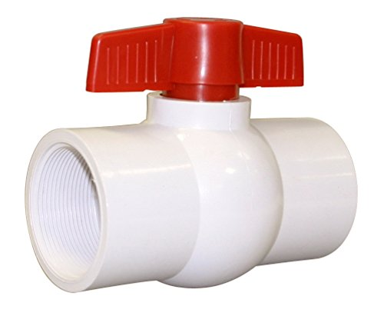A ball valve, as its name neatly suggests, is any valve that utilizes a ball to control the flow of substances from one opening to the next. The centre of the ball includes a port, sometimes called a bore. The ball valve is in the open position when this central port is aligned up in the same direction as the connected pipeline as such a positioning allows the fluid or gas to flow through. The ball valve turns to the closed position when the port becomes perpendicular, blocking the flow path and preventing any substances to continue moving through.

Fig. 3.2. (a) CPVC ball valve

While most standard ball valves are designed with special stop measures that permit only a 90-degree rotation, there are a few that offer a full 360 degrees. The 90-degree rotation is technically all that's required for the opening and closing of ball valves, but there are some applications where it's more desirable to have the full movement of the core. The ball valve is a notable industrial choice thanks to its reliable and air-tight sealing when in the closed position. This makes them particularly ideal for industries carrying potent chemicals or gasses that require secure and speeding shutoff, such as with natural gas. However, they shouldn't be used in intense throttling-like applications where constant wear on their seats could compromise their integrity.

Ball valve used is 2” CPVC Ball valve (Chlorinated Polyvinyl Chloride)

**3.3. Electric Motor**

Devices that convert electrical energy to mechanical energy, usually by employing electromagnetic phenomena.

Most electric motors develop their mechanical torque by the interaction of conductors carrying current in a direction at right angles to a magnetic field. The various types of electric motor differ in the ways in which the conductors and the field are arranged and also in the control that can be exercised over mechanical output torque, speed, and position

**3.3.1 Types of electric motors:**

**1.AC Brushless Motors:**

AC brushless motors are some of the most popular in motion control. They use induction of a rotating magnetic field, generated in the stator, to turn both the stator and rotor at a synchronous rate. They rely on permanent electromagnets to operate.

**2.DC Brushed Motors:**

In a DC brushed motor, brush orientation on the stator determines current flow. In some models, the brush’s orientation relative to the rotor bar segments is decisive instead. The commutator is especially important in any DC brushed motor design.

**3.DC Brushless Motors:**

DC brushless motors were first developed to achieve higher performance in a smaller space than DC brushed motors, and they are smaller than comparable AC models. An embedded controller is used to facilitate operation in the absence of a slip ring or commutator.

**4.Direct Drive:**

Direct drive is a high-efficiency, low-wear technology implementation that replaces conventional servo motors and their accompanying transmissions. In addition to being far easier to maintain over a longer period of time, these motors accelerate more quickly.

**5.Linear Motors:**

These electric motors feature an unrolled stator and motor, producing linear force along the device’s length. In contrast to cylindrical models, they have a flat active section featuring two ends. They are typically faster and more accurate than rotatory motors.

**6.Servo Motors:**

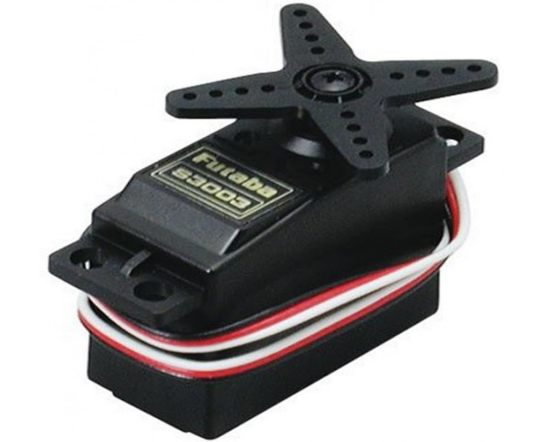A servo motor is any motor coupled with a feedback sensor to facilitate positioning; thus, servo motors are the backbone of robotics. Both rotary and linear actuators are used. Low-cost brushed DC motors are common, but are being superseded by brushless AC motors for high-performance applications.

Fig.3.3.1(a) Servo motor

**7.Stepper motor**

Stepper motors are DC motors that move in discrete steps. They have multiple coils that are organized in groups called "phases". By energizing each phase in sequence, the motor will rotate, one step at a time. With a computer controlled stepping you can achieve very precise positioning and speed control. For this reason, stepper motors are the motor of choice for many precision motion control applications.

**3.4. Stepper motor**

A stepper motor is an electromechanical device it converts electrical power into mechanical power. Also it is a brushless, synchronous electric motor that can divide a full rotation into an expansive number of steps. The motor’s position can be controlled accurately without any feedback mechanism, as long as the motor is carefully sized to the application. Stepper motors are similar to switched reluctance motors.

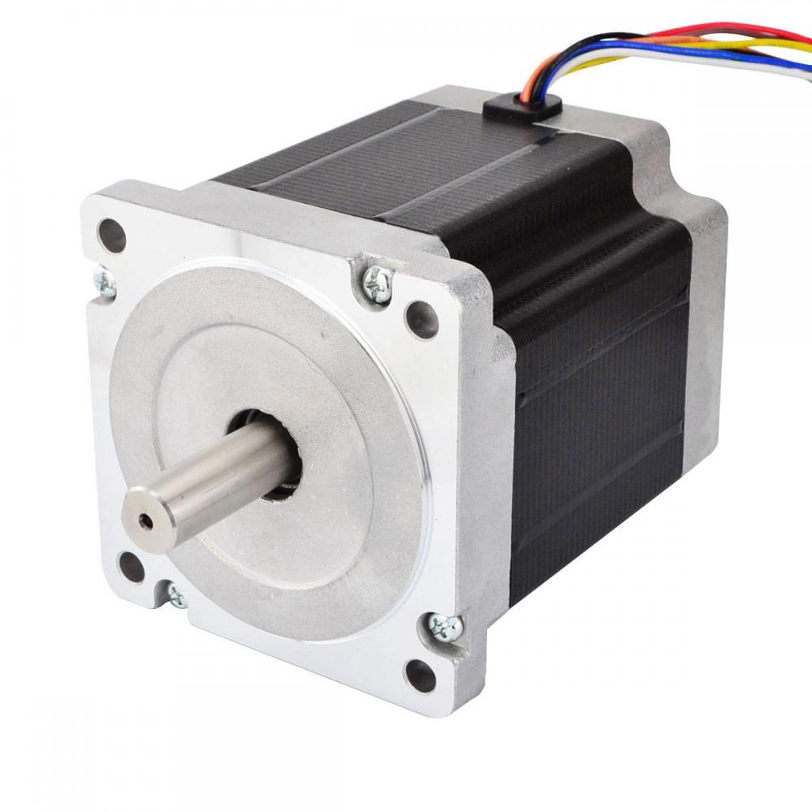

Fig 3.4 (a) Nema 34 Stepper motor

**3.4.1. Types of stepper motor**

There are three main types of stepper motors, they are:

1. Permanent magnet stepper
2. Hybrid synchronous stepper
3. Variable reluctance stepper

**1. Permanent Magnet Stepper Motor**: Permanent magnet motors use a permanent magnet (PM) in the rotor and operate on the attraction or repulsion between the rotor PM and the stator electromagnets.

**2. Variable Reluctance Stepper Motor**: Variable reluctance (VR) motors have a plain iron rotor and operate based on the principle that minimum reluctance occurs with minimum gap, hence the rotor points are attracted toward the stator magnet poles.

**3. Hybrid Synchronous Stepper Motor**: Hybrid stepper motors are named because they use a combination of permanent magnet (PM) and variable reluctance (VR) techniques to achieve maximum power in a small package size.

**3.4.2 Operation of Stepper Motor:**

Permanent Magnet stepper motors incorporate a permanent magnet rotor, coil windings and magnetically conductive stators. Energizing a coil winding creates an electromagnetic field with a north and south pole. The stator carries the magnetic field. The magnetic field can be altered by sequentially energizing or "stepping" the stator coils which generates rotary motion.

The diagram below illustrates step sequence for a two phase motor. In Step 1 phase A of a two phase stator is energized. This magnetically locks the rotor in the position shown, since unlike poles attract, when phase A is turned off and phase B is turned on, the rotor rotates 90° clockwise. In step 3,phase B is turned on but with the polarity reversed from Step 1, this causes another 90° rotations. In Step 4, phase A is turned off and phase B is turned on, with polarity reversed from Step2.Repeating this sequence causes the rotor to rotate clockwise in 90° steps.

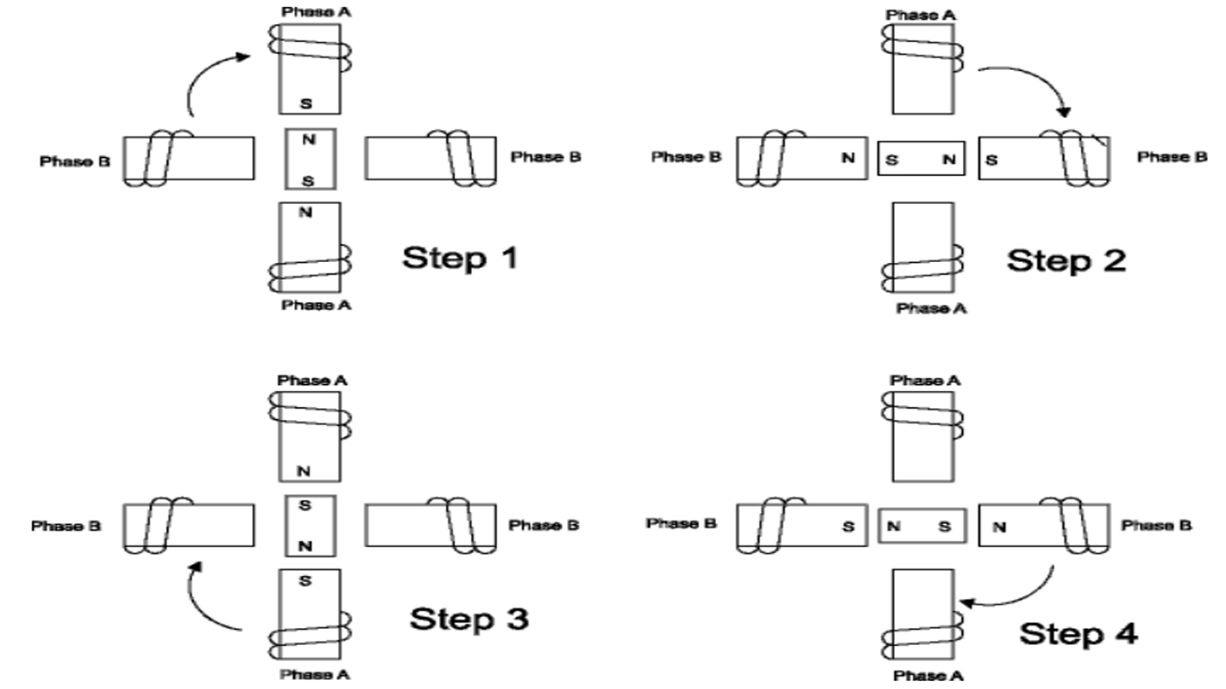

Fig. 3.4.2 (a) Operation of stepper motor

The stepping sequence illustrated in figure 1 is called "one-phase on" stepping. A more common method of stepping is "two-phase on" where both phases of the motor are always energized. However, only the polarity of one phase is switched at a time. With two-phase on stepping the rotor aligns itself between the "average" north and "average" south magnetic poles. Since both phases are always on, this method gives about 40% more torque than "one-phase on" stepping.

The motor can also be "half stepped" by inserting an off state between transitioning phases. This cuts a stepper's full step angle in half. For example, a 90° stepping motor would move 45 on each half step. However, half stepping typically results in a 20%-30% loss of torque depending on step rate when compared to the two-phase on stepping sequence. Since one of the windings is not energized during each alternating half step there is less electromagnetic force exerted on the rotor resulting in a net loss of torque.

**3.4.3 Advantages of Stepper Motor:**

1. The rotation angle of the motor is proportional to the input pulse.
2. The motor has full torque at standstill.
3. Precise positioning and repeatability of movement since good stepper motors have an accuracy of 3 – 5% of a step and this error is non-cumulative from one step to the next.
4. Excellent response to starting, stopping and reversing.
5. Very reliable since there are no contact brushes in the motor. Therefore, the life of the
6. The motors response to digital input pulses provides open-loop control, making the motor simpler and less costly to control.
7. It is possible to achieve very low speed synchronous rotation with a load that is directly coupled to the shaft.
8. A wide range of rotational speeds can be realized as the speed is proportional to the frequency of the input pulses

**3.4.4 Specifications of the incorporated stepper motor:**

* Step angle: 1.8º
* Configuration: 4 wire bipolar
* Holding torque: 45kgcm
* Phase current: 4A
* Voltage: 24V

**3.5 Microcontroller**

A microcontroller is a small computer on a single integrated circuit. A microcontroller contains one or more CPUs (processor cores) along with memory and programmable input/output peripherals.

Microcontrollers are used in automatically controlled products and devices, such as automobile engine control systems, implantable medical devices, remote controls, office machines, appliances, power tools, toys and other embedded systems

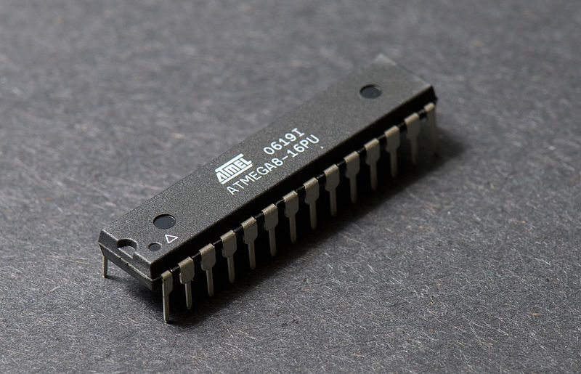

Fig 3.5 (a) Microcontroller

It is a small, low-cost and self-contained computer-on-a-chip that can be used as an embedded system. A few microcontrollers may utilize four-bit expressions and work at clock rate frequencies, which usually include:

* An 8 or 16-bit microprocessor.
* A little measure of RAM.
* Programmable ROM and flash memory.
* Parallel and serial I/O.
* Timers and signal generators.
* Analog to Digital and Digital to Analog conversion

**3.6 Arduino**

Arduino is an open-source electronics platform based on easy-to-use hardware and software. Arduino boards are able to read inputs - light on a sensor, a finger on a button - and turn it into an output - activating a motor, turning on an LED. You can tell your board what to do by sending a set of instructions to the microcontroller on the board.

**3.6.1 Different Types of Arduino Boards**

The list of Arduino boards includes the following such as

1.Arduino Uno (R3)

2.Lily Pad Arduino

3.Red Board

4.Arduino Mega (R3)

5.Arduino Leonardo

**3.7. Arduino Uno**

open-source microcontroller board based on the ATmega328P microcontroller and developed by Arduino.cc.

The board is equipped with sets of digital and analogue input/output (I/O) pins that may be interfaced to various expansion boards (shields) and other circuits. The board features 14 Digital pins and 6 Analog pins. It can be powered by a USB cable or by an external 9-volt battery, though it accepts voltages between 7 and 20 volts.

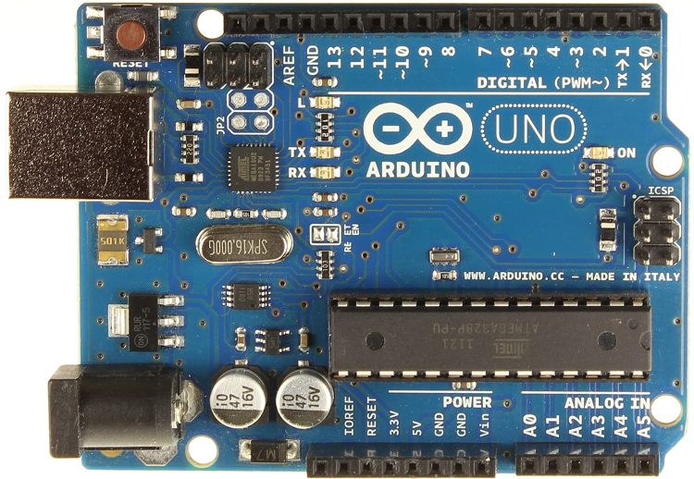

Fig. 3.7 (a) Arduino UNO board

**3.7.1 Technical specifications:**

* Microcontroller ATmega328P
* Operating Voltage 5V
* Input Voltage (recommended) 7-12V
* Input Voltage (limit) 6-20V
* Digital I/O Pins 14 (of which 6 provide PWM output)
* PWM Digital I/O Pins 6
* Analog Input Pins 6
* DC Current per I/O Pin 20 mA
* DC Current for 3.3V Pin 50 mA
* SRAM 2 KB (ATmega328P)
* EEPROM 1 KB (ATmega328P)
* Clock Speed 16 MHz
* LED_BUILTIN 13
* Flash Memory 32 KB (ATmega328P) of which 0.5 KB

used by bootloader

**3.7.2 Arduino programming**

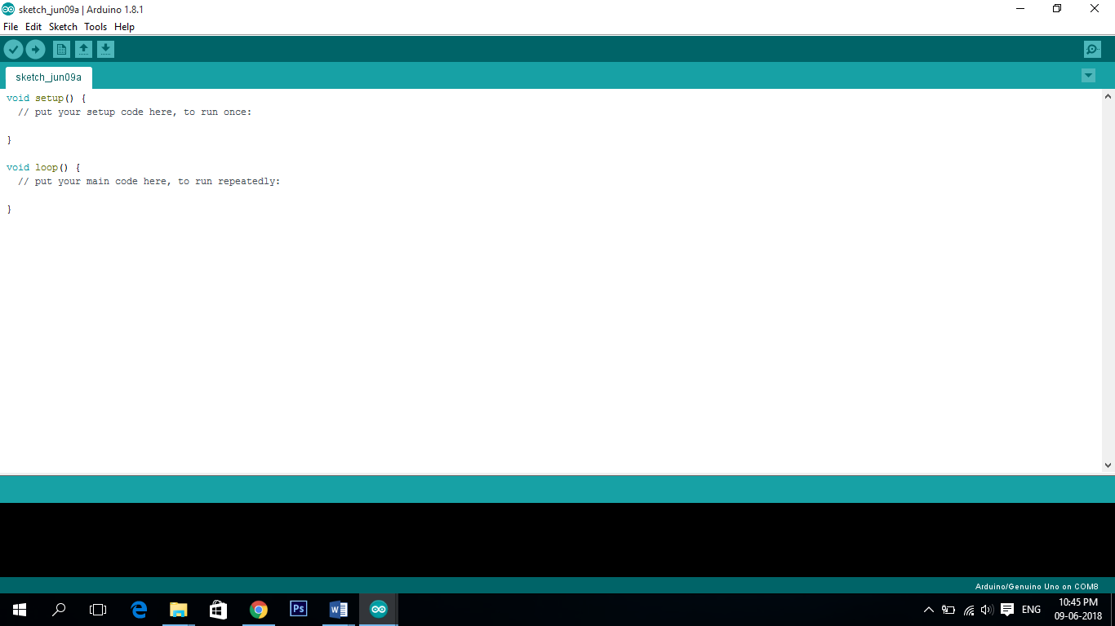Programs written using Arduino Software (IDE) are called sketches. These sketches are written in the text editor and are saved with the file extension. ino.

Fig. 3.7 (b) Arduino Software (IDE)

**3.8. Stepper Drive**

RMCS-1102 is Rhino Motion Controls new and improved DSP (digital signal processing) based micro-stepping drive for 1.8deg Bipolar Stepper Motors. It is designed for smooth and quiet operation without compromising on torque and control at higher speeds.

These chips keep the power that drives the motors separate from the power that is on the Arduino. The Arduino can't provide enough juice to power the stepper motors directly. This is why you have to use separate chips to sort of act as valves that control how the motor spins.

Another benefit that stepper driver chips provide, is that they provide fractional steps. This helps smooth out the motion of the stepper motor. Without fractional steps, stepper motors can have a tendency to vibrate or resonate at certain RPMs.

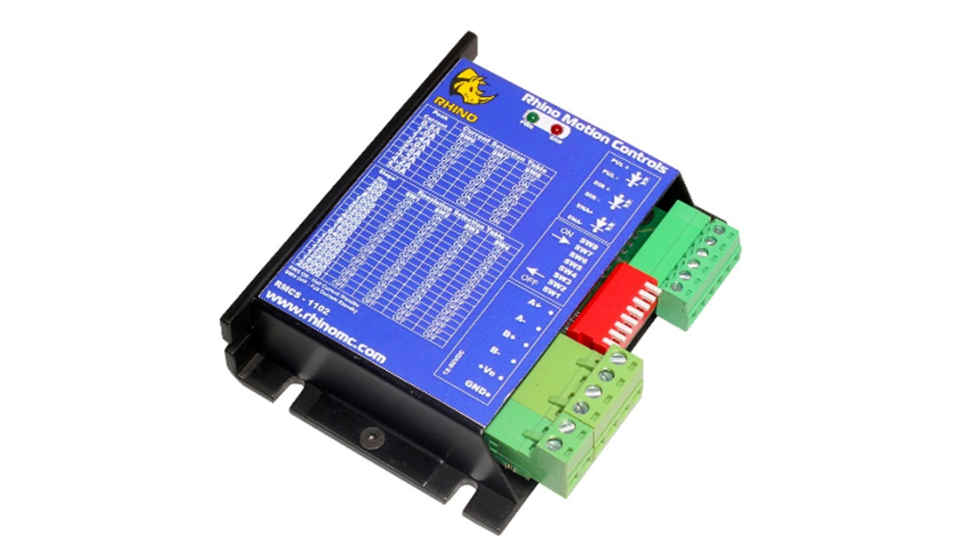

Fig 3.8 (a) RMCS – 1102 Stepper drive

**3.8.1 Micro-Stepping Drive Features:**

* Smooth and quiet operation at all speeds and extremely low motor heating.
* Industrial grade performance for 2-Phase Bipolar, 4-Phase and Unipolar Stepper Motors.
* Input supply voltage from 18VDc to 80VDC.
* Selectable peak coil current from 1A to 7A.
* Higher motor torque and higher speeds achievable due to advanced loop control algorithm.
* Short circuit protection for the motor outputs, over voltage and under voltage protection.
* LED indication for power and error states.

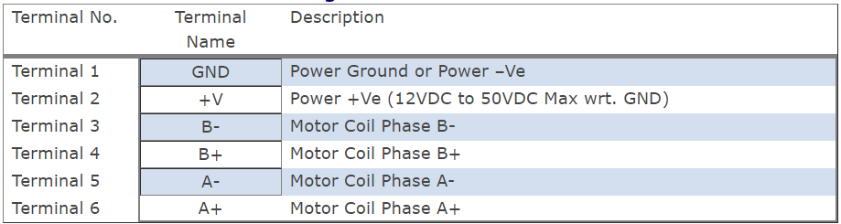**3.8.2 Power and Motor Terminal Assignments**

Table 3.8 (a) Power and Motor terminal assignments

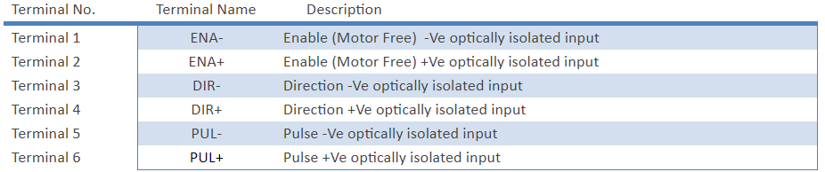**3.8.3 Pulse and Direction Input Assignments**

Table 3.8.(b) Pulse and Direction input assignments

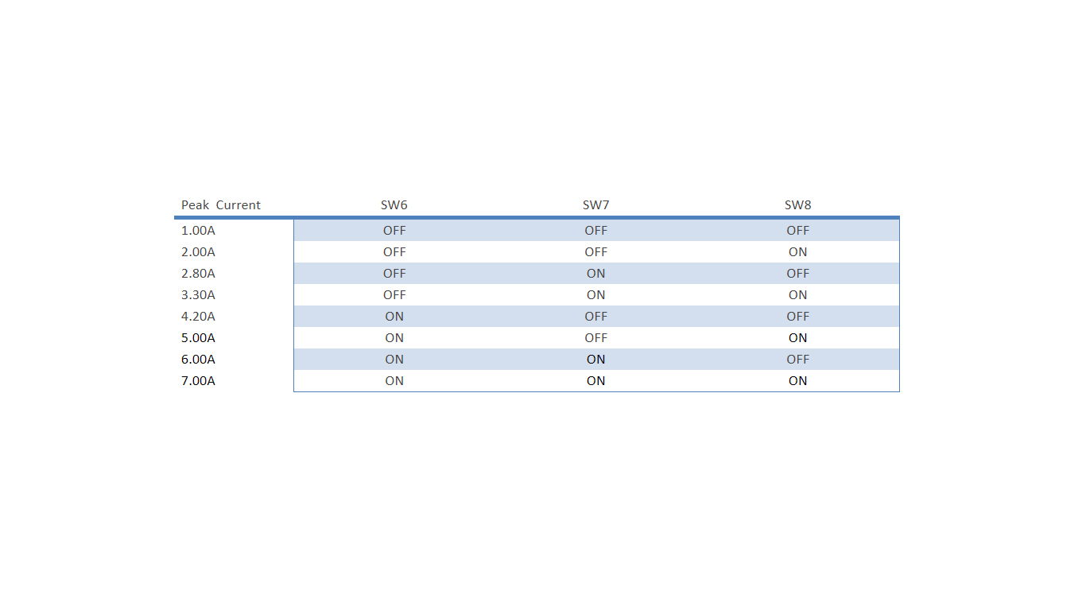**3.8.4 Motor coil current setting**

Table 3.8. (c) Motor coil current setting

**3.9 Switched-mode power supply (SMPS):**

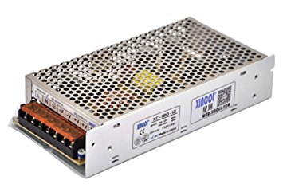 A switched-mode power supply (switching-mode power supply, switch-mode power supply) is an electronic power supply that incorporates a switching regulator to convert electrical power efficiently. SMPS transfers power from AC source (often mains power) to DC loads. We have used SMPS of 5A and 24V.

Fig 3.9 (a) Switched mode power supply (SMPS)

**3.9.1. Working of SMPS:**

The AC to DC converter SMPS has an AC input. It is converted into DC by rectification process using a rectifier and filter. This unregulated DC voltage is fed to the large-filter capacitor or PFC (Power Factor Correction) circuits for correction of power factor as it is affected. This is because around voltage peaks, the rectifier draws short current pulses having significantly high-frequency energy which affects the power factor to reduce.

the combination of the rectifier and filter, shown in the block diagram is used for converting the AC into DC and switching is done by using a power MOSFET amplifier with which very high gain can be achieved. The MOSFET transistor has low on-resistance and can withstand high currents. The switching frequency is chosen such that it must be kept inaudible to normal human beings (mostly above 20KHz) and switching action is controlled by a feedback utilizing the PWM oscillator.

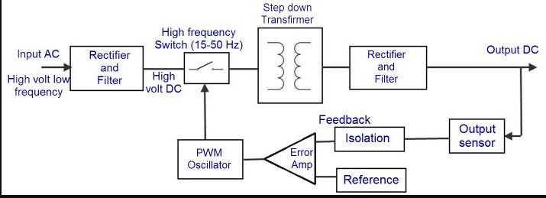

Fig 3.9.1 (b) working of switched mode power supply.

This AC voltage is again fed to the output transformer shown in the figure to step down or step up the voltage levels. Then, the output of this transformer is rectified and smoothed by using the output rectifier and filter. A feedback circuit is used to control the output voltage by comparing it with the reference voltage

**CHAPTER 4**

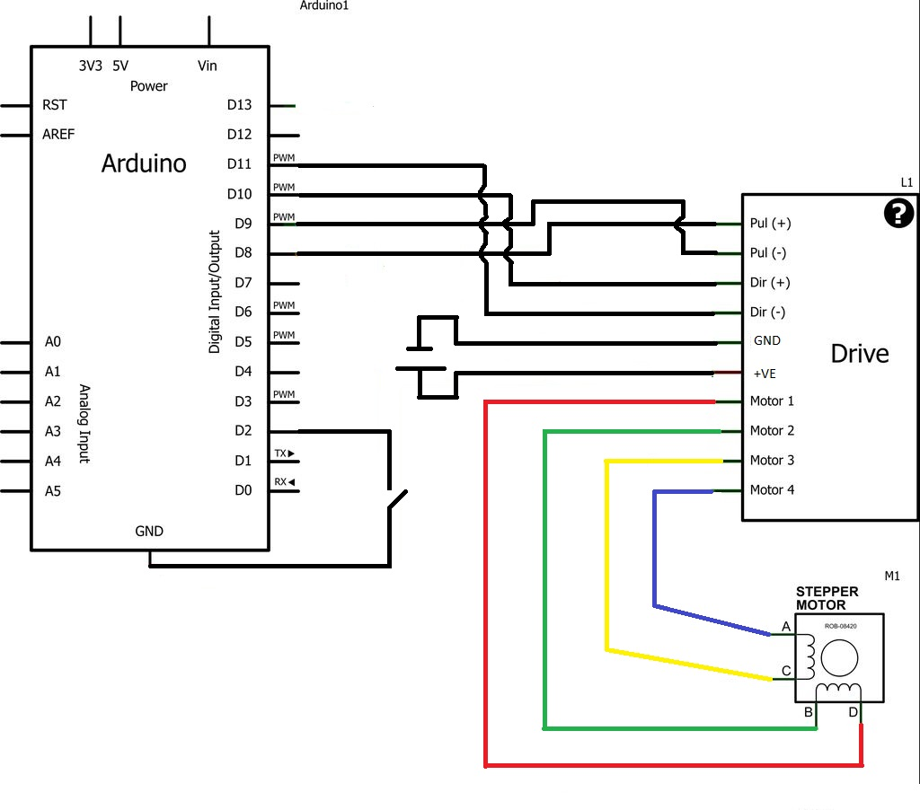 **CIRCUIT DIAGRAM AND CONNECTIONS**

Fig 4 circuit connections

Pin D11 of Arduino is connected to Dir(-) of drive

Pin D10 of Arduino is connected to Dir(+) of drive

Pin D9 of Arduino is connected to Pul (-) of drive

Pin D8 of Arduino is connected to Pul (+) of drive

Motor1 pin of drive is connected to coil end D of stepper motor

Motor2 pin of drive is connected to coil end B of stepper motor

Motor3 pin of drive is connected to coil end C of stepper motor

Motor4 pin of drive is connected to coil end A of stepper motor

D2 and ground are connected through a switch.

**CHAPTER 5**

**DESIGN AND IMPLEMENTATION**

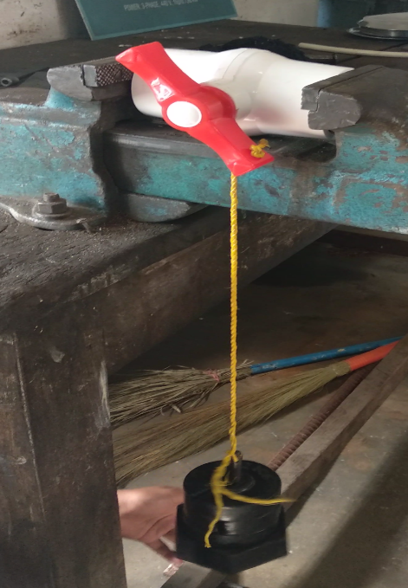**5.1 Design constraints for selection of motor**

Fig. 5.1.(a) experiment for calculation of torque

In order to calculate the torque, we have

T = W*r

Where, T = torque

W = weight

r = perpendicular distance

T = 5.250*6

= 31.5 kg-cm

Stepper motor is very user friendly and can be controlled using Arduino, it can be made to rotate in particular steps with specific degrees. A motor of any speed and torque can be controlled with suitable programming. In this project our inputs gave a result of 31.5 kg-cm torque, so we chose a motor of 45kg-cm.

**5.2. Design constraints for selection of driver**

Different drivers have different current driving capacities ranging from mile amperes to multi amperes. A motor driver also converts signals from Arduino to a form suitable for motor. It also can handle rotation specifications and speed specifications.

In this project we have chosen RMCS(Rhino motor controls)1101 we need to control the motor of 4.2A and 45kg-cm.

**5.3 Design constraints for selection of Arduino**

* Adoptability to small area
* Variable voltage range
* Feasible amount of memory
* Easy programming style
* Durability
* Ease of interfacing

**5.4 code for running the motor**

/*

Stepper Motor Control - one revolution

This program drives a unipolar or bipolar stepper motor.

The motor is attached to digital pins 8 - 11 of the Arduino.

The motor should revolve one revolution in one direction, then

one revolution in the other direction.

Created 11 Mar. 2007

Modified 19 May. 2018

by Benak Patel

*/

#include <Stepper.h>

const int stepsPerRevolution = 200; // change this to fit the number of steps per revolution

// for our motor

// initialize the stepper library on pins 8 through 11:

Stepper myStepper(stepsPerRevolution, 8, 9, 10, 11); //8&9 for PUL+ and PUL-;10&11 for DIR+ and DIR-

boolean state, lastState;

int flag=0;

void setup() {

pinMode(2,INPUT_PULLUP); //at all times signal read is logic 1 and only when the switch is pressed logic 0 is read

state = digitalRead(2); //digital read returns 1(TRUE) or 0(FALSE) depending on the switch position

lastState = state;

// set the speed at 20 rpm:

myStepper.setSpeed(20); //initialise stepper motor with rotation speed of 20 rpm

Serial.begin(9600); // initialize the serial port:

}

void loop() {

lastState = state;

state = digitalRead(2); //keepon reading the digital pin no.2 of Arduino

if ( state != lastState ) {

if(flag==0)

{

clkwise(); //call clkwise function to rotate stepper motor exactly 90'

delay(1000);

flag=1; //change flag to 1, to avoid repeatation

}

else

{

Anticlkwise(); //call Anticlkwise function to rotate stepper motor exactly 90' in opposite direction

delay(1000);

flag=0; //change flag to 0, to avoid repeatation

}

}

}

void clkwise()

{

Serial.println("clockwise");

myStepper.step(stepsPerRevolution);

delay(800);}

**CHAPTER 6**

**COST ESTIMATIONS**

Procurement of various components through shops and online markets for our functioning of our project. We purchased CPVC Ball Valve from the plumber shops. The stepper motors and step drive are purchased by online market Amazon and Robokits India. The other electronic components SMPS, Arduino, wire and connection procured through electronic shops.

**Particulars** **Cost**

1. CPVC Ball valve ₹150
2. Stepper motor ₹4500
3. Stepper driver ₹3300
4. Arduino UNO board ₹800
5. SMPS ₹700
6. Wire & switch ₹150
7. Miscellaneous cost ₹200

**Total**  **₹9800**

**CHAPTER 7**

**APPLICATIONS**

In the present scenario of our society which heavily incorporates water scarcity and human labor unavailability. This project stands and delivers all these needs in all possible way.

Case 1:

In agricultural land of 20 to 30 acres, for achieving sprinkler drip irrigation etc. a person needs to turn valve at each and every point which can be avoided and can be easily achieved with a single switch.

Case2:

City Corporation appoints workers to turn the valves at every certain area for water supply, even in case of leakage or breakage of pipes, the water supply need to be stopped and repaired, but our project overcome such problems by avoiding human interaction in these cases.

Case 3:

Multi storied buildings with multiple tanks at the top the water supply to one by one tank need to be operated every time by human by turning the valves which can be avoided

Case 4:

In nuclear power plant and steam power plants, the valves need to be operated which is hazardous which can be avoided. the intermediate flow of the fluid can be achieved by altering the Arduino program.

**CHAPTER 8**

**RESULT AND DISCUSSION**

This chapter provides results of operating the valve implemented using Arduino uno. This has been simulated using Arduino programming language. The complete software is implemented using Arduino UNO software on windows10 intel core i5 processor.

Programme is successfully dumped to Arduino.

Motor is rotated through 90º when switch is turned on for opening the valve.

For anti-clockwise rotation switch is pushed in opposite direction and made to close.

For controlled flow rotating angles of motor can be varied by programming.

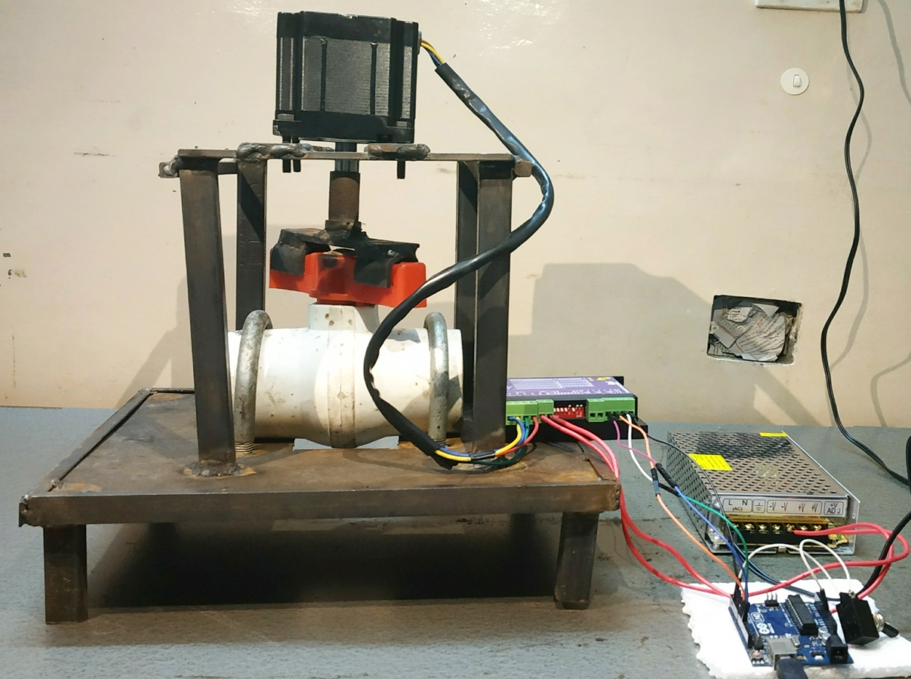

Fig. 8 (a) Model of the automatic valve control system

**CHAPTER 9**

**FUTURE SCOPE**

* Implementing using GSM
* To operate the valve depending on temperature and pressure.
* Fully automated control flow

**REFERENCES**

1. Ball valves, Issues and Material selections for Manufacturing”. *academia.edu.* Retrieved 24 June 2015

2. Tarun, Agarwal. “Stepper Motor- Types, Advantages and applications.

3.”The 8051 Microcontroller & embedded systems –using assembly & C.”-, Muhammad Ali Mazidi and Janice Gillespie Mazidi and Rollin D.McKinly; PHI,2006/ Pearson, 2006.

4. Mechatronics – Principles applications and concepts – Tata McGraw Hill 2003.

5. “Arduino Uno Rev3”. www.arduino.cc. Retrieved 20 February 2018.